## **Test Plan for AdMe Mobile App Testing**

## 

|  |  |
| --- | --- |
| General information | |
| Customer |  |
| Developer |  |
| Created by(Author) | Zimoglyad |
| Version | 1.2 |
| Status | For confirmation |

## 

|  |  |  |  |  |  |
| --- | --- | --- | --- | --- | --- |
| Revision History | | | | | |
| Version | Description | Author | Date | Approved by | |
| Author | Date |
| 1.0 | Creating | Zimoglyad | 23/03/2019 | Balabanoff | 24/03/2019 |
| 1.1 | Updating | Zimoglyad | 24/03/2019 | Balabanoff | 24/03/2019 |
| 1.2 | Updating | Zimoglyad | 25/03/2019 | Balabanoff | 25/03/2019 |

## 

|  |  |
| --- | --- |
| Related Documents | |
| Link | Document name |
|  | Checklist |
|  | Test plan |
|  | Test report |
|  | Bug report |

## 

## **1. Introduction**

## **1.1 Overview** At this Test Plan we will describe the scope of testing, test strategy, objectives, effort, schedule and resources which are required. The document also lists the different resources that are needed for the successful testing of the project.

**1.2 Objective**

The purpose of the test strategy is to formalize the testing process, plans and approaches to testing, interfacing process with the development team and the project team to achieve the high quality of the software product. The strategy takes into account the specifics of the functionality of the project AdMe

**1.3 The components and functions to be tested**

|  |  |  |  |
| --- | --- | --- | --- |
| ID | Module | Functions | Link |
| 1 | Authorization | Registration |  |
| 2 | Authorization via ... |  |
| 3 | Log in |  |
| 4 | Forgot password |  |
| 5 | Using Unauthorized |  |
| 6 | Log out |  |
| 7 | Newsfeed | New |  |
| 8 | Popular |  |
| 9 | News by sections | Search |  |
| 10 | Sections |  |
| 11 | Posts | Preview |  |
| 12 | Full view |  |
| 13 | Reaction(Like,Dislike,Fav,Comment) |  |
| 14 | Sharing |  |
| 15 | Favorite | Add\Remove |  |
| 16 | Notifications | Receiving notifications |  |
| 17 | My account | Profile editing |  |
| 18 | Remove account |  |

**1.4 The components and functions not to be tested**

|  |  |  |  |
| --- | --- | --- | --- |
| ID | Module | Functions | Link |
| 1 | Program code |  |  |
| 2 | Web services without the web interface |  |  |

## **2. Test Plan and Strategy**

**2.1 Module Testing**

**2.1.1 Objective**

The main objective of each module testing is to verify whether every single unit operates as intended. In each module, each function will be tested manually.

**2.1.2 Entry Criteria**

* planning phase has been finished
* testable units are available
* all functional requirements have been defined

**2.1.3 Exit Criteria**

* all planned test cases have been covered
* all the bugs found have been reviewed
* performance of key modules has been tested.

**2.1.4 The decisive factors of the project success**

* Compliance with a schedule for developing and approving specifications for the development of parts of the product.
* Compliance with the schedule and the completion of development and testing of all functionality in time.
* The application should not include known defects with critical and high priority at the time of the final version.
* Functional requirements are not changed at the last moment.

**2.1.5**

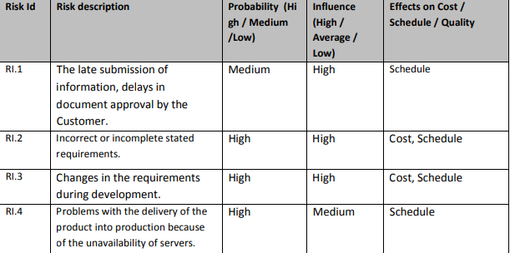

**2.2 System Testing**

**2.2.1 Testing Procedure**

* checklist preparation
* test executions
* bug reporting.

**2.2.2 Types of System Testing**

**Manual functional testing is regarded as the primary method of testing applications.**

**Performance Testing**

Performing testing is conducted to detect issues related to:

* memory consumption
* power utilization
* network connectivity
* operating in the background
* switching between applications

**Interrupt Testing**

As far as mobile devices have a huge range of functions, the work of the application may be interrupted by various reasons, e.g., an upcoming call, message, other apps notifications, mail, low memory warning, inserting a cable, etc. The application should be suspended and afterward launched from the place it was stopped without losing unsaved data.

**Usability Testing**

Usability testing is applied to check whether the application is easy to use and understand from the user’s point of view.

**Installation and Launch testing**

During installation testing, an engineer checks whether there are any issues during the installation, uninstallation, and updating of the application. Once the application has been installed, an engineer checks the launching process. The application must be loaded quickly and correctly. Closing the application should not require much time as well.

**Functional Testing**

All the functions and features of the application are tested to verify whether they operate according to the specification.

**2.3 Pass/Fail Conditions**

All the conditions when tests pass or fail are defined and described.

**2.4 Test Report**

Test Report helps to summarize testing activity in a formal way. It should contain:

* application name and overview
* the number of tests cases executed/passed/failed.

For each issue that has been encountered, the following information is provided:

* bug description
* bug status (open, fixed, etc.)
* bug location
* steps to reproduce an issue.

## **3. Schedules for Testing**

The deadline for testing and documentary is March 25th, 21.00. Testing is done, once:

* checklist is executed
* the rate of tests cases passed is satisfactory, e.g., 95%
* tests results have been accepted

## **4. Deliverables**

The list of testing deliverables contains:

* tests plan
* checklists
* bug reports
* test summary report.